Froodee.com 1

Of Dress Codes and Lifestyles

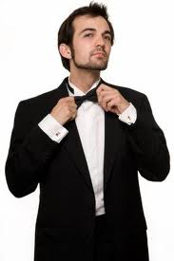

The way people dress up is typically dictated by the kind of lifestyle they lead. They follow what is deemed acceptable including both the written and unwritten rules contained in acknowledged dress codes. With the exception of people who intentionally go against societal standards to make a personal statement, people generally observe established standards as modified by certain preferences.

People have long attributed social significance to the manner of dressing. This has remained fairly true even with the much more relaxed dressing atmosphere we have at present. Even then, there are still minimal standards that guide trends and innovations and dressing. It is a worthy observation that no matter how far, present dressing standards have deviated from the long-established ones; there will always be a way to connect the present to the past.

In the area of formal wear, there are specific pieces of clothing and accessories that will most probably be forever identified with it. Some of these are the tailcoat, bow tie, waistcoat, detachable wing collar, shirt studs, and cufflinks. They have served distinguished and ordinary men alike in the past and they continue to do so during this time.

A fairly relaxed lifestyle is not an excuse to avoid some fancy dressing for important occasions. There are events that will call for some effort in dressing up. While women have more styles to choose from, men’s choices remain classic, making it easier for them to rise up to the event. A pair of USB cufflinks is able to provide a distinct formality in the overall attire.

White-tie and black-tie events call for some adjustment from the usual lifestyle dressing. Including a pair of cufflinks to spiff up the attire is not difficult at all especially now that it has become an accepted accessory for informal dressing.

